County of Lehigh, Pennsylvania
funds received through the American Rescue Plan Act (ARPA)
Annual Recovery Plan – State and Local Fiscal Recovery Funds (SLFRF)
2023 report (July 1, 2022 - June 30, 2023)
prepared by: Rick Molchany, Lehigh County Director of General Services
last updated: July 2023
Executive Summary
Lehigh County is located 65 miles north of Philadelphia and 89 miles west of New York City. This location provides a gateway for freight and services to the Northeastern United States.
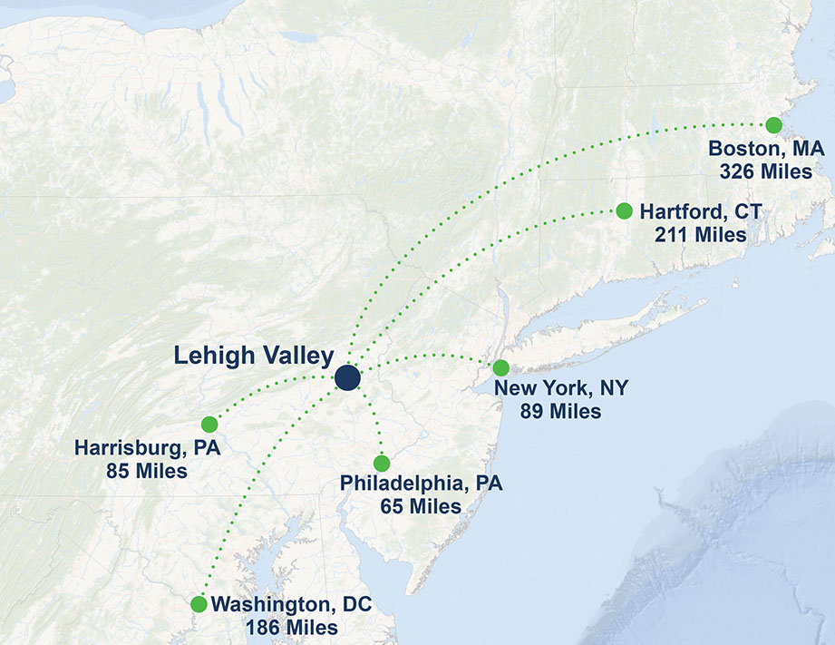
Lehigh County has > 375,000 residents with 30% of those living in Pennsylvania’s third largest city, Allentown. Our location to these deeply populated metropolitan areas cause deep concern for Covid19 infection spread. With New York and Philadelphia experiencing significant Covid19 infections, it was short order until we experienced very high infection rates. As of March 25, 2022, Pennsylvania Department of Health reports 258,892 Lehigh County residents have received at least one dose of the vaccine. This represents 70% of the population.
Lehigh County intends to use State and Local Fiscal Recovery Funds (“SLFRF”) to mitigate the public health and economic impact of the Coronavirus on the residents, small businesses, and nonprofit organizations in our community. On June 23, 2021, the Lehigh County Executive recommended and County Commissioners adopted, via Motion to accept the 2021 spending allocations; therefore, approving the following investments to promote a response to the pandemic and economic recovery.
July 2022 update:
On July 10, 2022, County Executive Phil Armstrong recommended, and Lehigh County Commissioners adopted, via motion, thus proving spending to the programs listed below. In addition to continuing to support the on-going initiatives, any additional programs will be listed and identified in this report.
July 2023 update:
On June 28, 2023, County Executive Phil Armstrong recommended, and the Lehigh County Commissioners adopted, via motion, thus providing spending to the programs listed below. In addition to continued support of on-going initiatives, additional programs will be listed and identified in this report.

We will continue to Covid19 test and promote vaccination for key staff and congregate setting residents, and continue to supply and then replenish personal protective equipment for County personnel; as well as, County wide first responders. In response to the negative economic impact, the County will use funds to provide assistance to Small Businesses and charitable non-profit Organizations in our community that have faced closures or revenue loss or are implementing new safety measures. Lehigh County will use payment from the “SLFRF” for the provision of government services to the extent of the reduction in revenue experienced due to the Covid-19 public health emergency. Key outcome goals include sustaining the small business sector in Lehigh County by providing crucial economic assistance to approximately 1,000 small businesses that have experienced an adverse economic impact due to Covid-19 that has threatened their ongoing operations and ensuring non-profit organizations remain viable to continue providing vital services to our community with a goal of assisting >100 civic organizations.
Lehigh County has experienced significant revenue reductions, especially at Cedarbrook Senior Living and Rehabilitation Center. Cedarbrook commissioned a revenue awareness study, with Affinity Health Services, to create baseline census, revenue and expense assumptions. The revenue is projected to see huge reductions through 2024. It is estimated, in fiscal year 2023, Cedarbrook revenue will see declines of $16.5m, and the decline will continue through fiscal year 2024. The accumulated revenue loss for Cedarbrook may approach $60.0m.
Lehigh County grows revenue via a variety of funding streams, with property tax revenue being a large segment. This segment was also the most consistent in our expectations from 2020 through 2023. Other segments, fees, court costs, jail costs among others were deeply off our revenue expectations. It is expected to see revenue declines of $7m, with little opportunity to claw back that loss.
The County projects revenue declines, due to Covid19 pandemic issues, in excess of $67.0m.

There are 25 municipalities in Lehigh County with the following demographics:
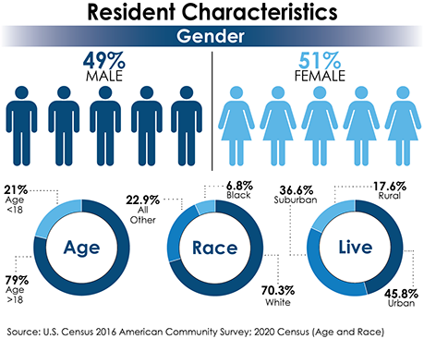
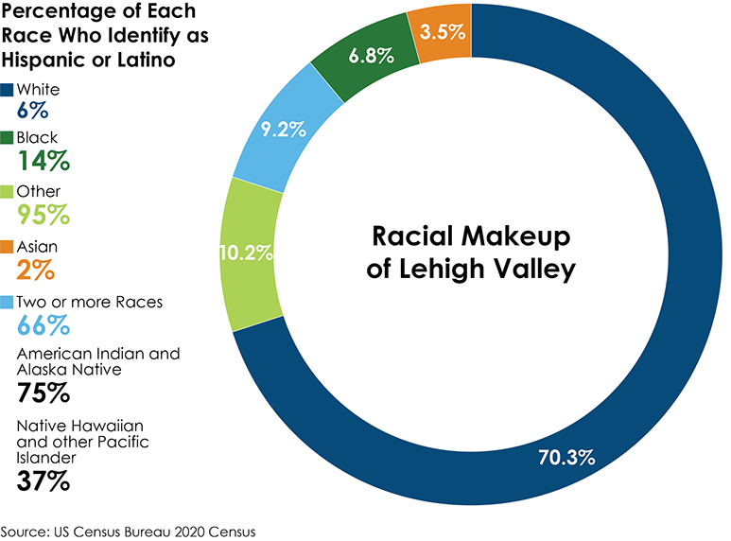

Equity means that all people have the same access to the resources, or opportunities, that are essential to their success. This is vital to supporting a sustainable region. Communities that prioritize equitable initiatives are found to be more successful and productive because there are more contributing hands and brains. Examining the disparities that exist in the Region is vital to informing public policy and furthering conversations with public, private and non-profit partners. Equity implications are engrained in everything from land use patterns to environmental justice concerns, employment opportunities to transportation access, and housing options to community design.

Spending Plan
1.0 Expenditure Category: Public Health
1.1 COVID-19 Vaccination
To minimize Covid19 infection spread, Lehigh County will continue to test and vaccinate our essential staff, including residents of congregate settings.
Cedarbrook Skilled Nursing & Rehabilitation Center (Cedarbrook) performs vaccination and testing via:
Residents: Upon Admission or Readmission from the hospital or an extended LOA, and then 2 and 5 days later. If there is an exposure from a positive staff, resident, or visitor, 2 days after the last exposure and then 5 days from the last exposure.
Staff: Exposure – 2 days and 5 days from last exposure to positive case. Twice weekly if exempted unvaccinated. Once or twice weekly if not up to date with Covid vaccination depending on if County positivity rate is moderate or severe.
Jail performs vaccination and testing via:
Inmates: Upon admission, 3-4 days later, again after quarantine, with symptoms, and with transfer to other institutions
Staff: will test and vaccinate upon request, and as staff is screened for symptoms
July 2022 update:
Lehigh County continues to vaccinate and test our Cedarbrook Nursing Home resident and Jail inmate populations.
July 2023 update:
Lehigh County continues to vaccinate and test our Cedarbrook Nursing Home resident and Jail inmate population.
1.4 Prevention in Congregate Settings
Lehigh County will improve Cedarbrook Skilled Nursing and Rehabilitation Center (Cedarbrook). Currently, Cedarbrook has three or four residents to a room, with communal bathrooms. This design was popular generations ago; however, it isn’t the design needed to fulfill resident expectations and efficient medical planning. By building a new wing, Cedarbrook will provide no more than two residents to a room, with toilet and shower accommodation per room. This will greatly reduce the risk of pandemic infection.
- Cedarbrook Mission: to provide the safety net for those County citizens who desperately require services
- New Wing at Cedarbrook
  - Build a New 240 Bed Wing; and
  - A wing opportunity (undefined revenue opportunity); and
  - B & C wings can be converted to apartments, offices, storage, other (keep the auditorium, family, kitchen); and
  - D wing bed count (after rebuilding): 246 beds
  - Mathematics: 670 beds required, New = 240 beds; D wing = 246 beds; FH = 184
  - Currently: Medicaid represents ~90% of resident earned revenue
  - This update project will support the Mission and permit Payer Mix revenue opportunities

Jail is built to house ~1,390 inmates; however, intense cooperation between Courts & Corrections were able to reduce the population to ~ 700. Even with the reduced population, we had to invent, then commission creative means to keep Covid19 infection spread under control.
Congregate settings in County Jail will be upgraded to include broadband access, new safety cell door screening, work release facility improvements, all in efforts to manage and reduce the spread of pandemic infection.
Jail improvements will include upgrades to re-entry services, job development skill training, and movements to provide home arrest versus incarceration via congregate settings.
Facility improvements for the Jail will be vetted by County Judiciary to ensure compliance with inmate standard operating procedures.
July 2023 update:
Jail programs to support reentry services include contracts with Centers for Humanistic Change and Career Link workforce development resources.
CHC: Anger Mgt, Interpersonal Skill Development, Parenting Skill Development, Decision Making Skill Development, and Release & Reintegration Skill Development.
Career Link: State supported career development program to assist reentry services.
These programs will assist to improve reentry; while minimizing recidivism.

1.5 Personal Protective Equipment
Lehigh County has responsibilities to serve our citizens, and could not simply close its operations; therefore, we instituted staff/visitor protections. From masks, to gloves, to disinfectant, to hand sanitizer our staff and visitors received protective equipment.
Lehigh County will continue to build inventory of protective equipment to ensure infection spread will be minimized.

1.7 Capital Investments or Physical Plant
Center for Disease Control, along with PA DOH have listed HVAC improvements as the key to minimizing Covid19 infection spread. Lehigh County will invest in HVAC upgrades, utilizing Johns Hopkins Research University recommendations. Recommendations include: bi-polar ionization, ultra-violet light, variable improvements to damper systems.
Reoccupying a building during the COVID-19 pandemic should not, in most cases, require new building ventilation systems. However, ventilation system upgrades or improvements can increase the delivery of clean air and dilute potential contaminants. Buildings that provided healthy, code-compliant indoor air quality prior to the pandemic can be improved for pandemic occupancy using less costly interventions. Below is a list of ventilation interventions that can help reduce the concentration of virus particles in the air. They represent a list of “tools in the mitigation toolbox,” each of which can contribute towards a reduction in risk. Implementing multiple tools at the same time is consistent with CDC’s layered approach and will increase overall effectiveness of ventilation interventions. These ventilation interventions can reduce the risk of exposure to the virus and reduce the spread of disease, but they will not eliminate risk completely.
The following tools identify ways to improve ventilation:
- Increase the introduction of outdoor air
- Use fans to increase the effectiveness of open windows
- Ensure ventilation systems operate properly and provide acceptable indoor air quality for the current occupancy level for each space.
- Rebalance or adjust HVAC systems to increase total airflow to occupied spaces when possible
- Turn off any demand-controlled ventilation (DCV) controls that reduce air supply based on occupancy or temperature during occupied hours
- Improve central air filtration
  - Increase air filtration external mix
- Ensure restroom exhaust fans are functional and operating at full capacity when the building is occupied
- Inspect and maintain exhaust ventilation systems in areas such as kitchens, cooking areas, etc. Operate these systems any time these spaces are occupied. Operating them even when the specific space is not occupied will increase overall ventilation within the occupied building
- Use portable high-efficiency particulate air (HEPA) fan/filtration systems to enhance air cleaning (especially in higher risk areas such as a nurse’s office or areas frequently inhabited by people with a higher likelihood of having COVID-19 and/or an increased risk of getting COVID-19)
- Generate clean-to-less-clean air movement by evaluating and repositioning as necessary, the supply louvers, exhaust air grilles, and/or damper settings, this recommendation is easier to accomplish when the supply and exhaust points are located in a ceiling grid system
- Use ultraviolet germicidal irradiation (UVGI) as a supplemental treatment to inactivate SARS-CoV-2 when options for increasing room ventilation and filtration are limited
- Invest in bi-polar HVAC upgrades as a supplemental treatment to inactivate SARS-CoV-2 when options for increasing room ventilation and filtration are limited
- In non-residential settings, run the HVAC system at maximum outside airflow for 2 hours before and after the building is occupied

Lehigh County’s Historic Old Courthouse can alleviate congestion and overcrowding by renovating the facility to operate two Common Court Pleas courtroom and two Magisterial District Courts. This courthouse required significant investment to improve mechanical and electrical systems, including HVAC to provide better accommodations for trials.
Design notes:
- Major Renovation
  - This is a historic building and this structure is listed on the National Register of Historic Places
  - Removal of installed mechanical systems and utilities, including HVAC, plumbing, electrical, fire detection/protection and communications. All demolition and removals shall include proper accommodation of asbestos and hazardous paint, in accordance with existing law and regulation
  - Provide architectural design and plans for structural repairs that shall.
- Provide interior space allocation and design from a County generated needs analysis and in conjunction with present Lehigh County studies
- Prepare design and associated construction documentation for replacement of installed mechanical/electrical systems and utilities, including mechanical, HVAC, plumbing, electrical, fire detection/protection and communications. Installed elevator to be replaced with state-of-the-art equipment meeting accessibility standards. A sprinkler (fire suppression) system shall be designed to encompass the entire structure. Provide interior design services and coordination appropriate for the degree and extent of interior renovation undertaken
- Work must be approved by appropriate state and local government agencies, and be in compliance with all mandated and applicable laws, guides and codes (BOCA, Life Safety, Fire Protection, ADA, OSHA, PHMC, etc.)
July 2023 update:
Lehigh County has completed the renovation of the Historic Courthouse, and has improved air quality, lessened Court density, and provided a healthier experience.
Lehigh County continues to upgrade our HVAC systems to provide facility improvements to reduce the spread of airborne pathogens. Project is nearly complete.

1.8 Other COVID-19 Public Health Expenses
County wide responders provide the first interactions during emergency events. Lehigh County will continue to support efforts by maintaining inventories of protective equipment. In addition, County will search for county-wide equipment opportunities that can assist municipal first responders in their duties.

1.10 Mental Health Services
Lehigh County is considering investment of SLFRF funds as leverage to increase capacity of the existing Crisis Intervention Support Program. This Co-Responder serves as a behavioral health professional that is positioned alongside police officers to respond to behavioral health calls by helping de-escalate situations and connect people in crisis to needed mental health resources.

Lehigh County will continue to build upon our foundation of mental health support. Investments will be made via Human Services to reach out to those in need and provide a safety net.

July 2022 update:
Lehigh County is assigning funding allocations to support the HUB mental health support
program with providing support to all Lehigh County police departments and the
District Attorney’s office. This program will support ground breaking efforts to
de-escalate police interactions with mental health-needy citizens.

July 2023 update:
Lehigh County has assigned funding to support traumatic mental health support for youth incarcerated, or those who require restrictive treatment holding. In addition, we have partnered with a local mental illness provider (Kidspeace) to assist in youth walk in services.

1.12 Other Public Health Services
Lehigh County will continue to support social programs that reduce homelessness, childhood violence, drug and alcohol dependency.
Lehigh County does not have a sanctioned Health Bureau. Funds via SLFRF will be used to study and map out a plan for the County to improve public health.
July 2023 update:
Lehigh County has partnered with Community Services to create a transitional approach for recently paroled youth offenders. This program will provide after school and Saturday intensive treatment support that will provide a safe landing after incarceration.
Lehigh County will partner with local Counties to create a safer detention holding program for youth who need incarceration. This program will be closer to our County, and provide family support during the holding process.

2.0 Expenditure Category: Negative Economic Impacts
Based on recent feedback from the small business community and community stakeholders, Lehigh County is considering additional small business/nonprofit grant programs targeted to
entities continuing to demonstrate revenue losses due to COVID-19. These programs may consist of general small business assistance as well as nonprofit assistance.

Employment. The labor market has become more service-oriented than goods-producing, but manufacturing – the sector once dominated by Bethlehem Steel, but now carried by such companies as Air Products, Just Born and Mack Trucks – still employs more than 30,000 people.
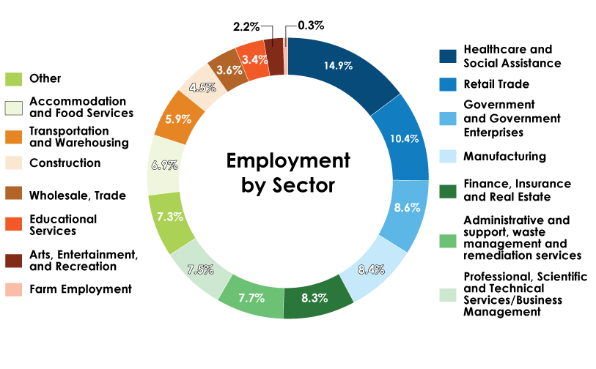

An aging population, increased life expectancy and advances in medical technology have helped make the healthcare industry the Lehigh Valley’s largest jobs sector, employing nearly 60,000 people. While healthcare employment is and will continue to be in strong demand, transportation and warehousing are growing fast. That again can be credited to a location that gives the region easy access to three major interstates and the ports of New York, New Jersey and Philadelphia.

2.9 Household Assistance: Small Business Economic
Lehigh County COVID-19 Relief Small Business Grant Program
As part of the funds received under the American Rescue Plan (ARP), the County of Lehigh allocated ten million dollars, less delivery fee for administrative services, to provide small business support to the small, vulnerable and disadvantaged businesses in Lehigh County. The COVID-19 Small Business Grant Program opened July 30, 2021 to assist businesses in mitigating the effects of mandated closures and sharp declines in revenues due to COVID-19.
Due to the anticipated demand, the Lehigh County Department of Community and Economic Development (DCED) has partnered with the Greater Lehigh Valley Chamber of Commerce to assist with the administration and marketing of this grant program. The Chamber will collect all applications via an online portal as well as collect all required supporting documentation. The Chamber will also promote the program to all eligible businesses within Lehigh County, regardless of Chamber membership status.
Lehigh County businesses with fewer than 100 employees may apply for up to a $15,000.00 grant for COVID-19 related expenses. Grants are not to exceed 25% of the business’s 2019 annual gross revenue. Eligible businesses must operate primarily in Lehigh County and must file a Pennsylvania tax return. Applicants will self-certify that 51% or more of revenues are generated in PA. Priority will be given to businesses who have not received funding from other sources and applicants must include the other grants/loans received. Awards will be provided on a first-come, first-serve basis.
Once grant applications are received, Lehigh County DCED will process applications for administrative completeness. The applications will then be reviewed with final recommendations made by the County Executive to the Board of Commissioners who will consider each application for approval or denial. With the County of Lehigh currently operating under an Emergency Declaration, the Board can approve projects by Resolution (only 1 required reading) instead of the normal Ordinance process which requires two readings and an additional 10 day waiting period. This process will be very instrumental in sending the funds to the recipients in an expedited fashion.
Program guidelines have been created and are published and available on the County and Lehigh Valley Chamber of Commerce websites.

Eligible uses of funding include:
- Expenses related to implementing safer operating procedures such as physical plant changes to enable social distancing, enhanced cleaning efforts, barriers or partitions, or Covid-19 vaccination, testing, or contact tracing programs.
- Expenses to mitigate periods of closure including payroll and benefits costs, costs to retain employees, mortgage, rent, or utilities costs, and other operating costs.
- Expenses to mitigate financial hardship including technical assistance, counseling, or other services to assist with business planning needs.
- There can be no duplication of benefits. Expenses already covered by other relief measures including state grants or loans, US SBA Paycheck Protection loans, local or regional grant and/or loan programs are not eligible uses for funding under this grant program.
The COVID-19 Relief Small Business Grant Program will consist of several rounds during 2021 in order to assist businesses as quickly as possible. The goal of the Small Business Grant Program is to assist at least 700 small businesses who certify their business has suffered an adverse economic impact due to COVID-19 and this grant is crucial to support their continued survival. Upon completion of this program there will be an accurate account of the number of businesses assisted which will determine if this goal has been met.

July 2022 update:
Once the program opened in July 2021, over 700 businesses applied to this program. In order to assist businesses as quickly as possible, several lists of businesses were recommended and sent forward to the Board of Commissioners. From September 2021 through February 2022, 627 businesses were awarded $7,515,615.00. The program continued through the end of May 2022, where an additional 182 businesses received $1,919,924.00 in funds from the Small Business Grant Program. Thus, 809 small businesses in Lehigh County received a total of $9,435,539.00. The goal of this program remains, in that it is critical for the County of Lehigh to assist these small businesses that certify they have suffered an adverse economic impact due to COVID-19, and this grant program was crucial to support their continued survival.
July 2023 update:
Lehigh County completed support for small business in 2023. Nearly $9.8m of COVID-19 economic support which provided necessary funding for their continued business survival. The program is now closed.

2.10 Household Assistance: Aid to nonprofit organizations
Lehigh County COVID-19 Relief Non-Profit Grant Program
As part of the overall American Rescue Plan (ARP), the U.S. Department of the Treasury awarded to the County of Lehigh, Pennsylvania, a total of $71,735,692.00 through the Coronavirus State and Local Fiscal Recovery Funds (SLFRF) program to support our response to and recovery from the COVID-19 public health emergency. At the June 23, 2021, Lehigh County Board of Commissioners public meeting, an initial County spending plan was supported and approved by our elected Board. In that initial plan, the County proposed a $3.5M total investment of ARP funds ($1,000,000.00 to be paid out in 2021 and another $2,500,000.00 to be spent in 2022) to support local non-profit agencies in Lehigh County that show a demonstrated need for assistance.
Due to the anticipated demand for this program, the Lehigh County Office of Community and Economic Development partnered with the United Way of the Greater Lehigh Valley to help advertise this grant program, solicit proposals, accept and review applications, and assist with the administration of this program as a whole. Information about this program is available at:
https://www.unitedwayglv.org/find-resources/for-non-profits
To be eligible to receive ARP funding from the County, an organization requesting assistance has to be recognized as a non-profit organization under Section 501 ( c ) of the Internal Revenue Code, applicants have to verify as part of the application process that they are in compliance with the Commonwealth of Pennsylvania’s directives regarding COVID-19 safety precautions at the time of application, and the budgets and narratives submitted have to show that the proposed projects will serve Lehigh County residents. The intent of our program is to fund as many projects as possible, so to stretch the available dollars as much as possible, it is possible that some awards may be subject to partial funding. Our program will not require any local matching funds.
Applicants will be given a deadline by when to submit a self-certifying application along with some other required documentation through the United Way’s website. Funded projects will have a set amount of time within the overall timeframe of when ARP funds must be spent to be able to incur project-related expenses. Applicants will be asked to declare other ARP or CARES Act funds that have been received. Applicants are to be reminded to apply for COVID-related expenses either already incurred or yet to be incurred that fall outside of an already-existing approved operating or capital budget approved by their organization.
An internal committee consisting of three (3) members will be created to review applications and make recommendations for funding. The committee will be comprised of a member of the Lehigh County Administration (Director of Community and Economic Development), an elected member of the Lehigh County Board of Commissioners, and a staff member of the United Way of the Greater Lehigh Valley (UWGLV). Once the committee has come up with a recommended slate for funding, the County Executive will make final recommendations to the Lehigh County Board of Commissioners (BOC), and the full BOC will consider each application for approval or denial. With the County of Lehigh currently operating under an Emergency Declaration, the BOC can approve projects by Resolution (only 1 required reading) instead of the normal Ordinance process (2 readings) in the interest of time and to help get the needed funding out the door and into the hands of the intended recipients as soon as possible.
An internal Request for Payment form will be created. The payment request will be processed by the County’s Fiscal Office, and the County will only pay the approved non-profits. An initial budget and project narrative will be submitted to the County’s Office of Community and Economic Development, and amended budgets are to be submitted as needs change, and it will be requested that a final budget also be submitted to the County after all funds have been spent for proper tracking purposes, and all documentation is to be retained for audit purposes.
General program guidelines are to be created for local non-profits interested in submitting an application to remind them that this grant funding is available to help eligible non-profit organizations respond to the negative impacts of the COVID-19 public health emergency. Eligible expense categories are to include (but not be limited to) projects providing services to Lehigh County residents that:
- Provide assistance for food access (grocery shopping resources, pantry resources, or other meal-delivery services);
- Reduce social isolation for all ages through virtual programming, resources to provide connectivity and equipment, and training to build skills;
- Provide assistance to bridge the digital divide in grades pre-K through 12 through training, connectivity, and equipment;
- Provide resources to assist with added maintenance requirements brought on by COVID-19, such as additional PPE and sanitizing and disinfecting requirements in order to operate safely and in accordance with mandated guidelines;
- Provide assistance to create an environment that can be safely experienced by Lehigh County residents due to requirements brought on by COVID-19, i.e., social distancing, masks, etc.;
- Provide resources to people experiencing homelessness or supporting housing and homeless prevention; and
- Provide positive youth development; social, emotional, and mentoring services; support at home learning materials and virtual tutorials; and the purchase of curriculum for in-person or online digital platforms with summer learning. (These services can either be provided virtually or in-person.)
As part of the project monitoring, projects are to report back to the County regarding the number of residents served and how they were served, along with the impact the funds received will have on the local community. Successful applicants must identify the community need and how the service provided will mitigate that need. Finally, funded projects must also clearly identify the demographics of those served.
July 2022 update:
In the end, during the 7/1/21 – 6/30/22 reporting period, the application window for non-profits was from 9/7/21 – 10/15/21. The period in which expenses were able to be incurred was from 12/30/20 – 12/31/22. A total of $1,000,000.00 was released by the County of Lehigh. The County was able to award grants to 44 non-profit organizations, with grant amounts ranging from as small as $1,500.00 to the largest grant being awarded in the amount of $45,000.00.
July 2023 update:
Lehigh County accepted Round 3 applications with the help of the United Way of the Greater Lehigh Valley through 9/30/22. The period of time in which eligible expenses were able to be incurred was from 1/1/22 – 12/31/23. A total of $904,000.00 was awarded to 59 recipient organizations. Grants ranged in size from $1,000.00 to $150,000.00, with the average award amount being approximately $15,300.00. These funds were awarded in April 2023.

5.0 Expenditure Category: Infrastructure
5.5 Clean Water: Other Sewer Infrastructure
Lehigh County is currently assessing infrastructure needs of its County Water/Sewer Authority and will consider these projects within the context of existing county infrastructure programs.

Lehigh County Authority (LCA) is a regional water and sewer authority providing service throughout Lehigh County in eastern Pennsylvania. The system provides service to approximately 200,000 people in the City of Allentown, PA, and surrounding neighborhoods. Like all utilities across the nation, LCA is challenged by aging infrastructure, climate change, and financial constraints. The region is growing and
the need for utility services is expanding.

The highest priority is assigned to this project:

Project | Brief Description | Cost Estimate
Trexlertown Interceptor Upgrade  Project | Address hydraulic capacity requirements in a restricted area of the regional system that must be addressed prior to new  industrial customer connections. | $4 Million

July 2023 update:
No financial impacts to date.

5.17 Broadband: Other Projects
The Lehigh County Executive & Commissioners are also strongly considering setting aside SLFRF dollars to support broadband expansion efforts---either through direct investment in currently shovel-ready projects or long-term planning for future expansion. Over the past year, Lehigh County has worked with internet service providers, municipalities, intermediate units, and its broadband consultant to not only assess the overall need for broadband in the county, but also pursue funding for shovel-ready projects in known areas of need.

Investing SLFRF funds in both “urban and rural” broadband will support a strong recovery by expanding digital access to workers, families, and students currently struggling to participate in remote work/educational settings. Improving remote work/education conditions in Lehigh County will further allow more flexibility for workers and students to safely participate in remote scenarios especially in instances of COVID resurgence.

Broadband expansion is critical in the technological environment that we live; however, we lack consistency across social economic regions:

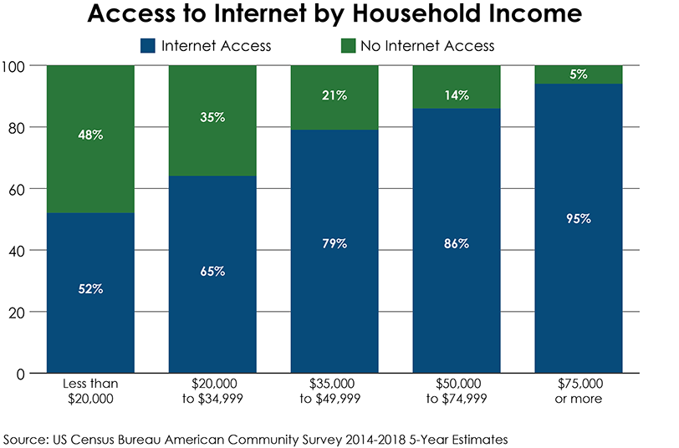
At this time, we are projecting funding for this initiative; however, Commonwealth of Pennsylvania has not finalized the State plan.
July 2023 update:
No financial impacts to date.

6.0 Expenditure Category: Revenue Replacement
Using SLFRF funds to replace lost revenue will allow Lehigh County to restore its full
functional capacity and ability to deliver its full range of services to residents in 25
municipalities, both rural and urban, and many times targeted to the most vulnerable
citizens. The wide range of critical functions and services provided by Lehigh County
directly to residents lends itself to making revenue replacement a priority use consistent
with a strong and equitable recovery as it has the potential to impact every community
county-wide.

6.1 Provision of Government Services
As noted previously, replacing revenue as a priority use of SLFRF funds supports over
375,000 Lehigh County residents by ensuring the continued function of county
departments providing critical services in areas including:

- Tourism and Recreation:
  - Coca Cola Park Upgrade
  - Zoo-Velodrome
  - Burnside Plantation
  - Seed Farm
  - Parks

- General IT Support
Provide equipment to service remote working opportunities that will assist us in reducing the covid19 infection spread.

- Improved effectiveness:
  - Conversion to MS 365
    - Promote safer environment for remote work security
  - Conversion from Hard to Scanned HR Files
    - Create access to HR files to conduct business in a remote work place setting
  - ERP System
    - To continue efforts to improve internal systems, we will continue to support upgrades to ensure business and internal systems can be managed in a potential work remote setting

- Transportation is what keeps our economic growth possible. Much like weather and air quality, transportation impacts virtually everyone. Traffic congestion in the Lehigh Valley is defined as high-density traffic flow in which speed and freedom to maneuver are severely restricted, and comfort and convenience have declined, even though flow remains stable. More than 100,000 residents commute outside the Lehigh Valley for work each day, contributing to an average daily commute time of 26 minutes region-wide.
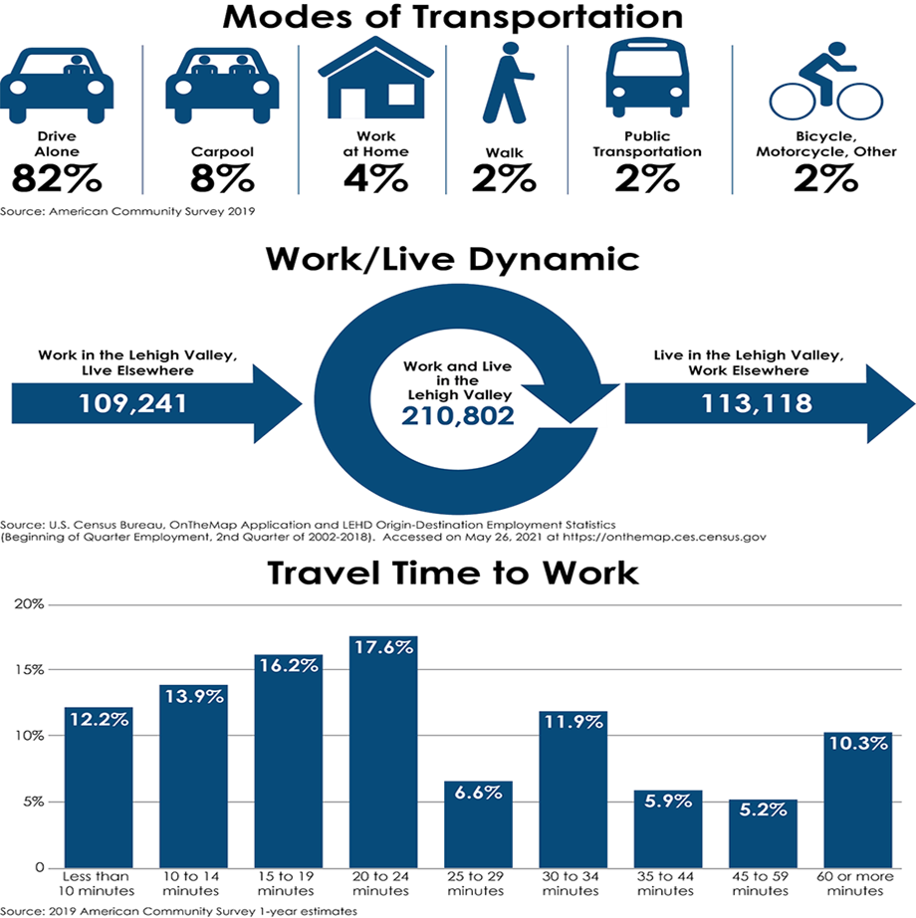

  - Bridges
    - At this time, we are studying the potential need
  - Airport Authority Support
    - At this time, we are studying the potential need
  - Lanta Authority Support
    - At this time, we are studying the potential need

- Cedarbrook Skilled Nursing and Rehabilitation Center
Revenue shortfall replacement to maintain quality of life for residents

- Lehigh County General Revenue Fund
Revenue shortfall replacement to maintain quality of life for citizens

- Strategic Planning Programs to support climate, housing, equity analysis
  - Housing concerns are obvious in Lehigh County. The COVID-19 Pandemic has had a dramatic impact on the global economy and the effects in the Lehigh Valley have been particularly troublesome in the areas of housing and employment. Lehigh County, Lehigh Valley Planning Commission, in partnership with the Federal Reserve Bank of Philadelphia, has worked to analyze the risk faced by residents and workers across the Lehigh County, so government, non-profit and community leaders can direct resources to where they’re needed most. The region’s growth and success have always been directly tied to people being able to find attainable housing and their ability to pay for that housing rests with the region’s employment market.
  - A household that is cost-burdened is paying more than 30% of gross income on housing costs, and is more likely to struggle to pay for other basic needs such as utilities, healthcare, childcare, transportation and food. They are also likely to have less disposable income, which impacts the economic vitality of their community and the larger region. The analysis shows that these households at risk of being unable to afford rent or mortgage payments are located throughout the region, in rural, urban and suburban municipalities. In fact, some communities have neighborhoods in which more than 80% of households are cost-burdened.
  - It should be noted that cost-burdening is not always a forced situation, as some households elect to devote more income to housing costs than is recommended by housing experts as a lifestyle choice, to live closer to a job or to live in a specific school district, for example. However, the unexpected and rapidly evolving employment conditions caused by the COVID-19 Pandemic are likely to increase the risk of foreclosure and evictions for households that were previously financially stable, as well as those lower-income households that have limited financial flexibility.

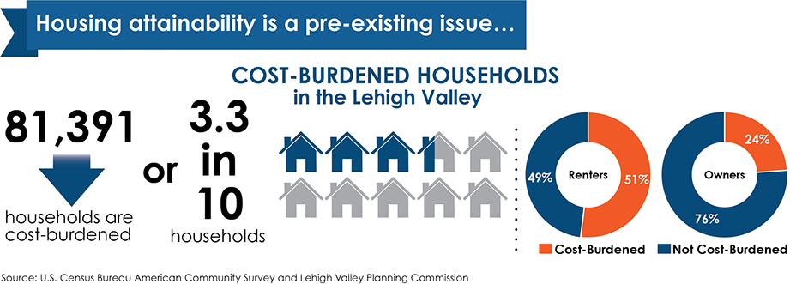

- Health and Climate concerns, especially with our failing air quality measurements place incredible impact on the health and wellbeing of our citizens. We are dependent upon carbon fuels, and this increased the need to study and correct environmental impacts.

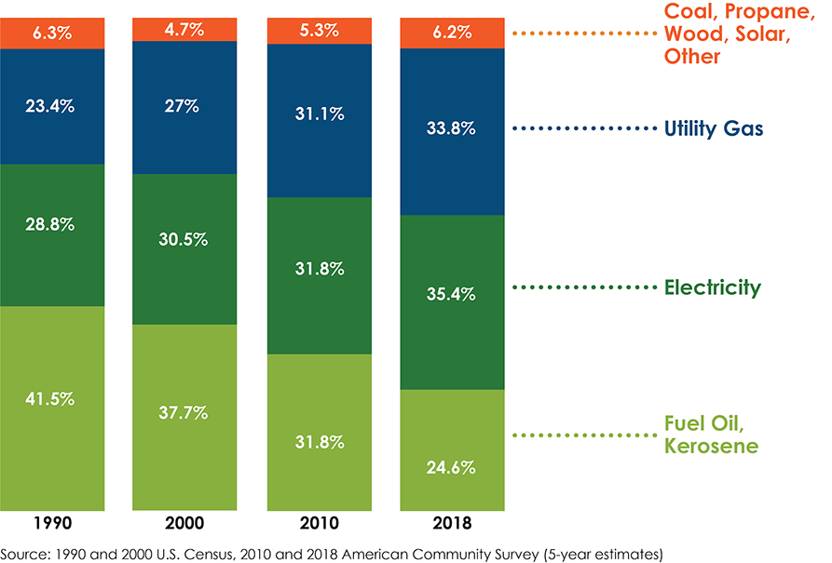
- 1,000 miles of streams and more than 460 miles of nature trails, most people in the Lehigh Valley have close access to outdoor activity. And 77% say they are physically active – a rate almost equal to the national average of 78%.
- 19% of residents in the region smoke and 18% percent drink excessively, and in defiance of national and statewide trends, neither of those numbers have improved since 2010.
- Risky health behaviors, such as smoking cigarettes and excessive consumption of alcohol, can lead to a wide range of health issues and early death.
- Physical environment plays a key role as well. An LVPC public opinion survey from 2018 indicates that the top two categories people cited as very important to preserve were air quality at 91% and water resources at 87%. Air pollution triggers asthmatic episodes, sends people to hospitals, shapes how children’s lungs develop and can even be deadly. The region’s location between two mountain ranges reduces air quality in the Valley. Common air pollutants include ozone, particulate matter, carbon monoxide, nitrogen dioxide and sulfur dioxide - all from burning various fuels for non-transportation and transportation-related uses.
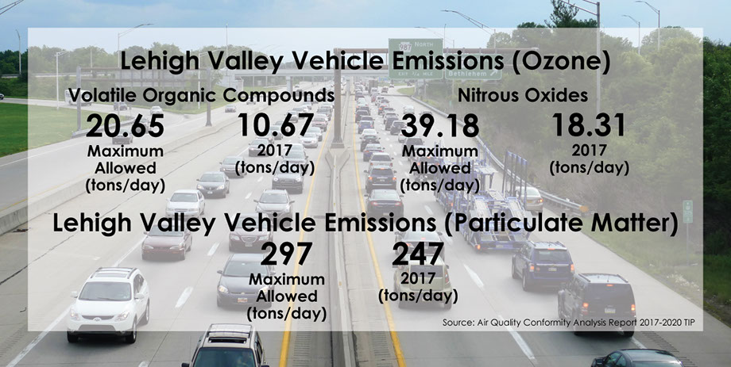
- In the Pennsylvania County Health Rankings, quality of health is based on health behaviors, environmental factors (such as quality of the air and water), availability of affordable and appropriate housing, contributing social factors (such as the population’s education and employment rates), and the overall access to healthcare. The rankings also account for health outcomes determined by life expectancy and number of premature deaths. Considering the high ranking of life length compared to the low ranking of quality of health, people in the Valley are living longer, yet unhealthier lives.
- The results of the Lehigh Valley Health Network's 2019 Community Health Needs Assessment Health Profile Lehigh and Northampton Counties are indicative of how a person is affected by their health quality, particularly later in life. Senior citizens make up a growing proportion of the Lehigh Valley’s population, and in 2015, over 19% of those over age 65 were being treated for depression.
- Health is tied directly into all aspects of people’s lives. Recreational opportunities affect how often people exercise. Transportation, housing, education and economic opportunities affect people’s mental health, and determine environmental conditions and one’s accessibility to care, but the most effective way to improve quality of life is by practicing good health behaviors and eliminating bad ones. Opioid addiction is a growing crisis on a national level, and the Lehigh Valley is not excluded from its impacts. In 2016, Lehigh and Northampton County coroners reported 96 opioid overdose deaths, with an additional 73 from multiple drugs that may be opioid-related, according to a report by The Morning Call. If this crisis should continue to rise, it will have greater impacts on the economy, environmental conditions, and health deterioration.
- Planning can help people’s behaviors by identifying health issues and providing opportunities to address them, such as supporting infrastructure that increases access to alternative transportation methods, such as walking and biking.
July 2023 update:
Lehigh County has partnered with Lehigh Valley Planning Commission to study and develop programs to improve climate concerns. Air and water quality are important to the health and wellness of our citizens.
Lehigh County has partnered with Lehigh Valley Planning Commission to study housing and develop programs to improve housing equity. The Federal Reserve, along with the Urban Land Institute have joined on as support partners. Our goal will be to evaluate housing needs, provide mapping support for effective zoning/planning, and provide financial opportunities for developers to control costs and provide affordable housing. In addition, we have dedicated financial funding support for developers to create equitable housing options to meet local citizen needs.
Human Relations has initiated a study to improve our workforce development in the post COVID19 environment.
Job Development through economic support will be provided for projects that support local, challenged and currently underperforming class of underemployed labor force.
Our investment into Coca Cola Park, minor league baseball venue continued in 2023 with funding to support this quality of life initiative. The Park is a local citizen favorite, and provides healthy family fun to our constituency.

